**Understanding Customer Behavior for Business Growth**

**The Problem: Why Aren't Customers Returning**

John owns a busy retail store, but he has a problem—**customers are not coming back often**, and sales keep going up and down.

His marketing team **thinks discounts** will bring customers back. So, they **send discounts to all past customers** without checking if they really need them.

After one month, **the results are bad**. A few customers use the discount, but **most do not return**, and sales **do not improve**.

JHON’s busy retailstore…….…

JHON’s uncrowed retailstore..

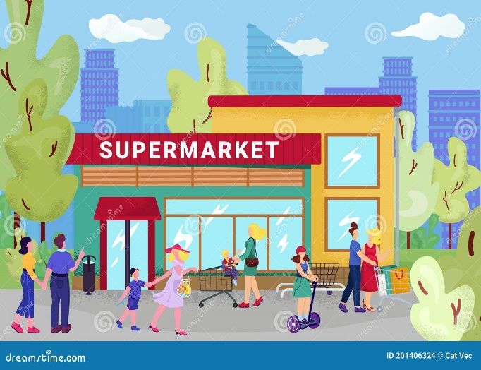 



Jhon thinking…

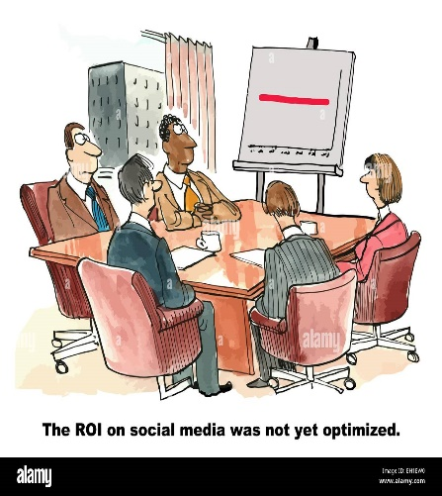

**SALE**

He decides meeting with his team.

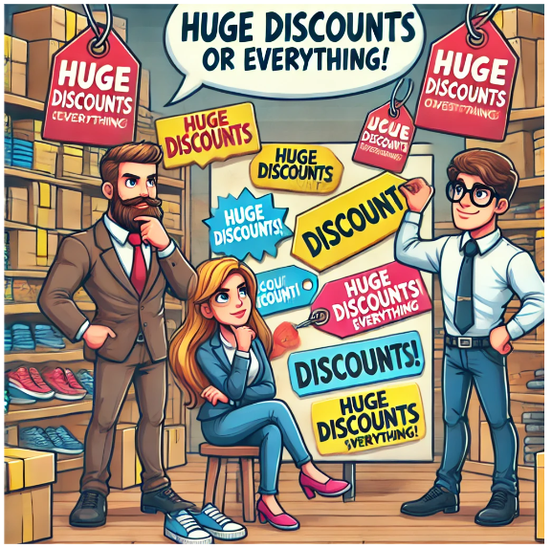

they decide to give discount to all product

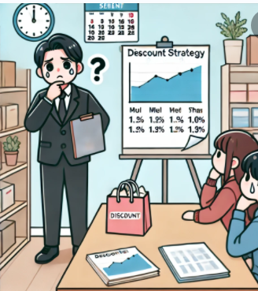

The plan was dropped.

John is **confused and worried**. He asks **Sarah, his data analyst**, to find out what went wrong.

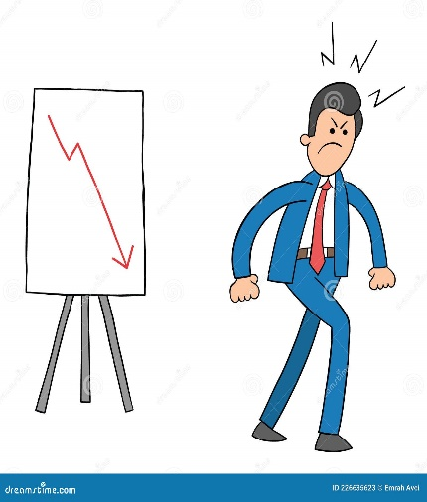 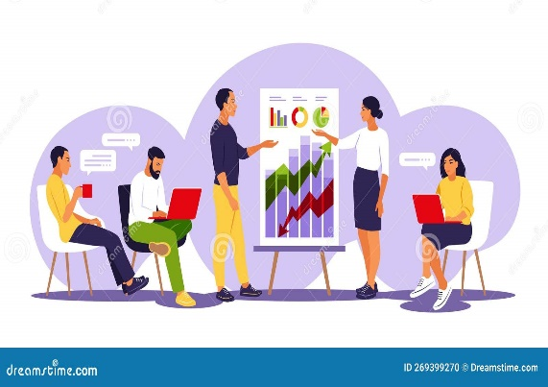

Consulting with his team

JHON confused

Instead of giving discounts to everyone, Sarah suggested

**DATASET DESCRIPTION:**

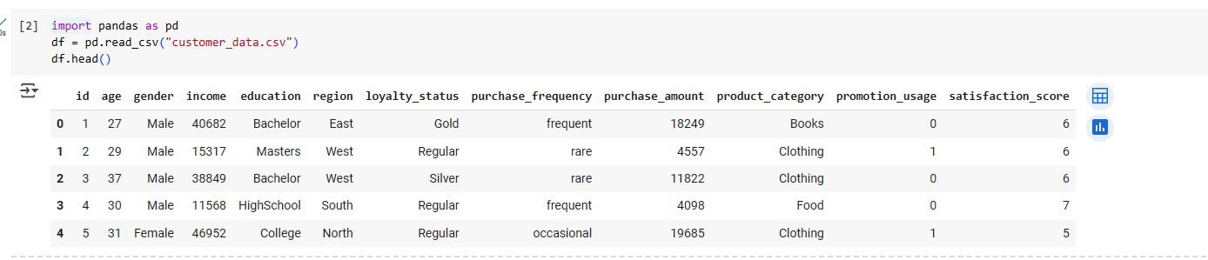

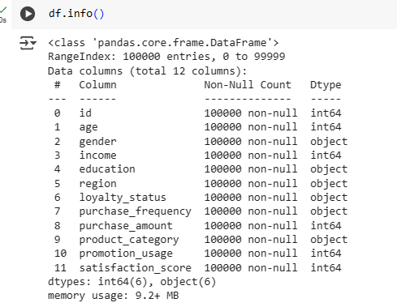

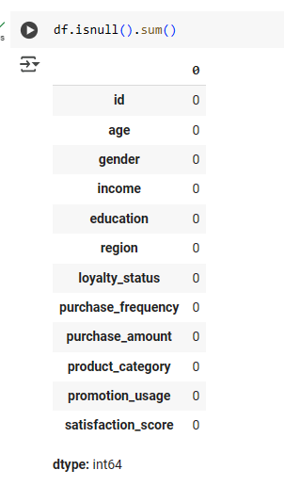

**1.ANALYSIS1:**

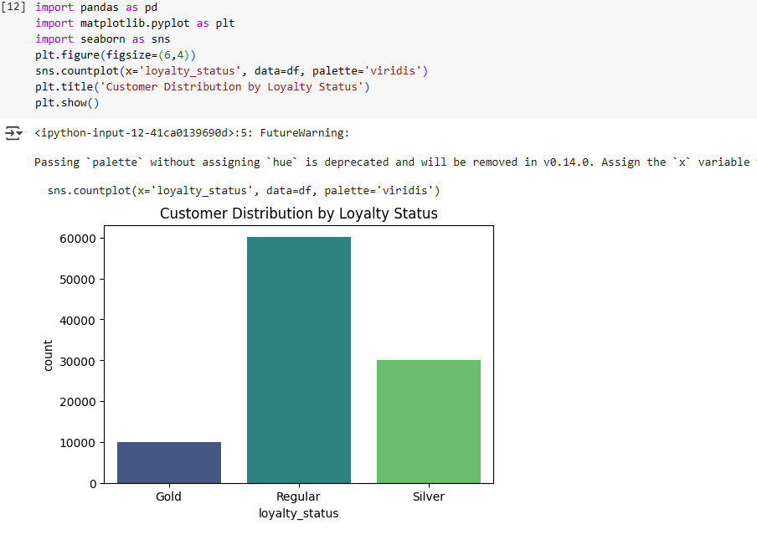

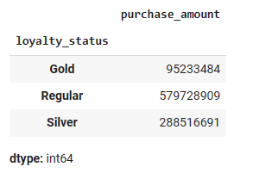

**Target High-Value Customers**

* **Insight:** Gold customers have the highest purchase amounts but are the least in number.
* **Action:** Offer **exclusive perks** (personalized discounts, early access to sales, or reward points) to keep them engaged.

2.ANALYSIS2:

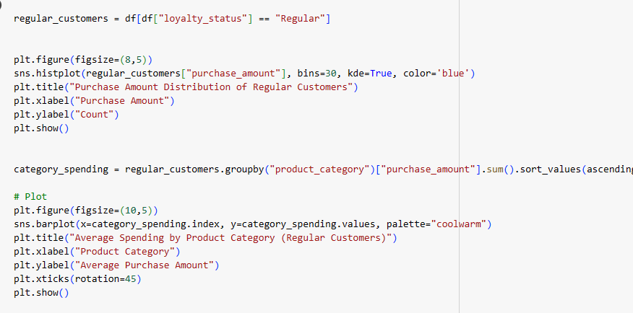

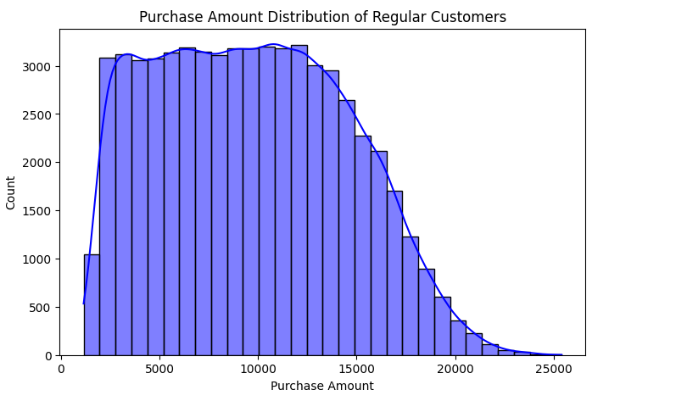

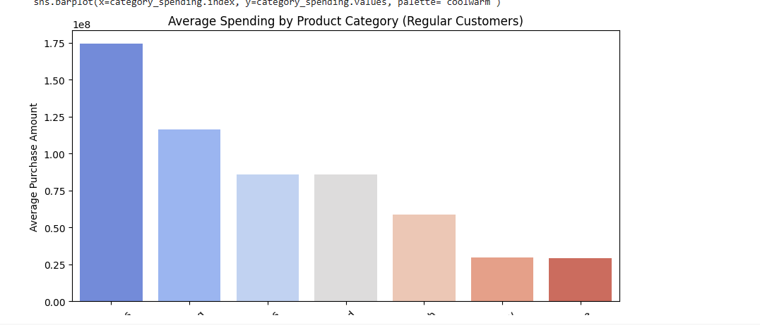

**Improve Engagement with Regular Customers**

* **Insight:** Regular customers are the largest group but have a lower purchase amount.
* **Action:**
  + Send **personalized recommendations** based on past purchases.
  + Introduce a **tiered loyalty program** to encourage more frequent shopping.

ANALYSIS3

**Optimize Promotions**

* **Insight:** Not all customers use promotions.
* **Action:**
  + Identify which promotions work best and **stop mass discounts**.
  + Use **targeted campaigns** for frequent shoppers instead of giving discounts to everyone.

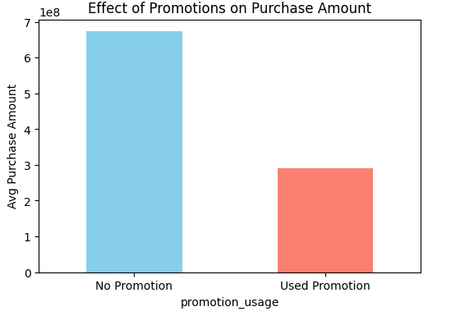

ANALYSIS4

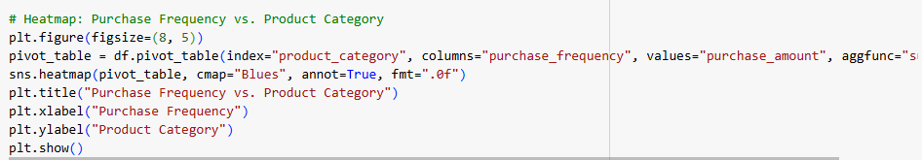

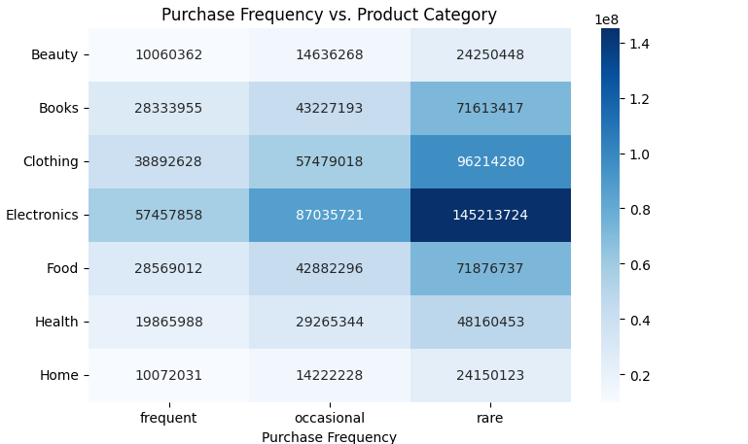

BASED ON THE PRODUCTS WE GIVES DISCOUNT

ANALYSIS5:

BASED ON THE AGE WHICH PRODUCTS HAS BEEN FAVOUR TO BE SELL

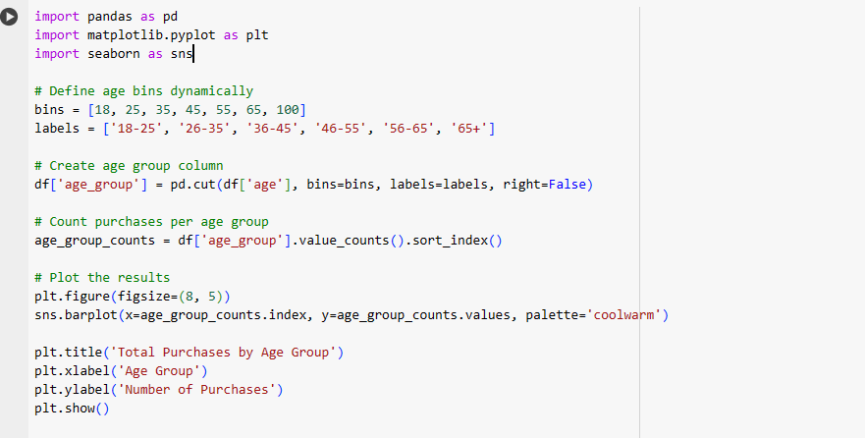

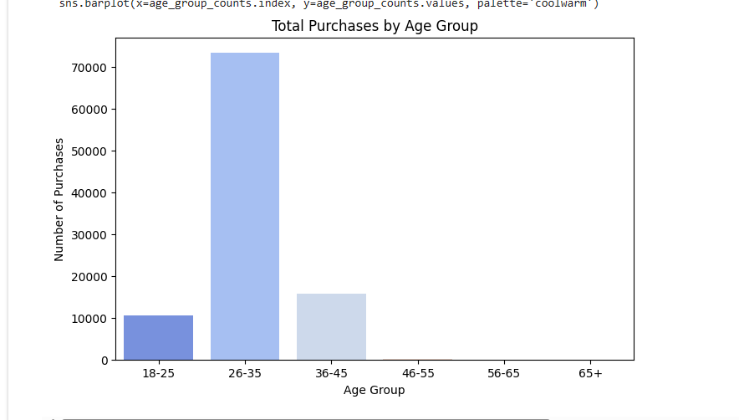

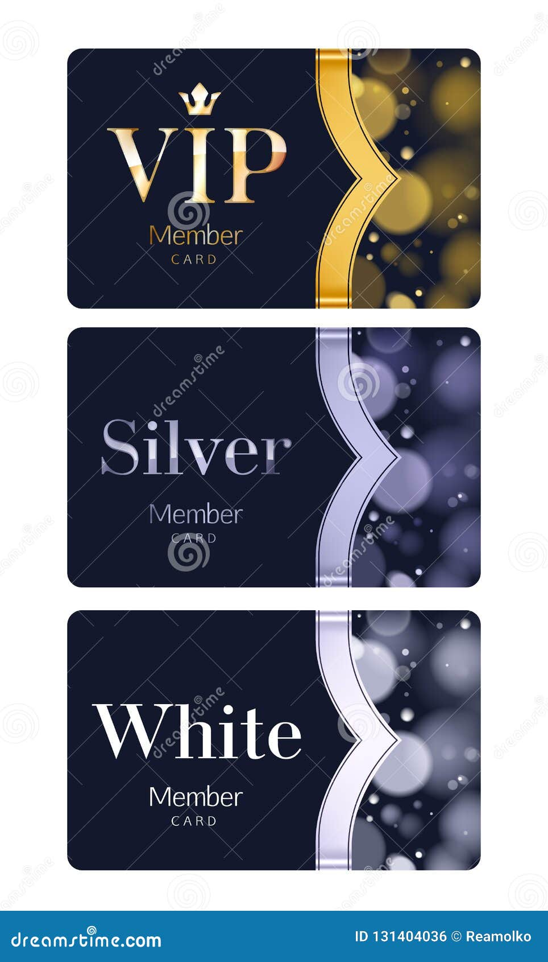

Discount for frequent shoppers



**COMPARISON:**

Before using data, John and his marketing team relied on assumptions to boost sales, offering discounts to all customers without analyzing their purchasing behavior. This broad and unfocused approach led to minimal improvements, as many customers did not respond to the promotions, and overall sales remained stagnant.

After incorporating data, the strategy became more targeted and effective. By analyzing purchase frequency, loyalty status, and promotion usage, John identified high-value customers and tailored promotions accordingly. Instead of mass discounts, he focused on personalized offers, improved product stocking based on demand, and optimized promotions for better engagement. This data-driven approach led to better decision-making, increased customer retention, and improved sales performance.